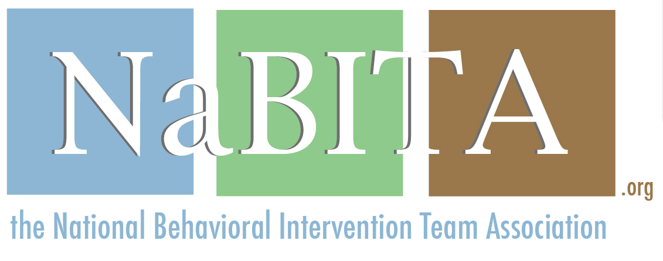
RESPONSE DOCUMENT
2018 District Host for NaBITA Training Events
Name of prospective host: _________________________________________________

City: ___________________________________________________ State: ________________

- Dedicated Contact
Response: Outline contact information for the individuals who will serve as NaBITA’s point of contact for all planning purposes and inquiries leading up to and during the training event. These individuals should be available for regular calls and/or emails with NaBITA staff to discuss logistics, ask questions, etc.

Contact 1
- Name
- Professional title
- Department
- Email address
- Phone number

Contact 2
- Name
- Professional title
- Department
- Email address
- Phone number

Please also confirm that these individuals (to the best of their abilities) will remain in regular contact with NaBITA throughout the planning process and with attendees during days of training. At the four-month mark from the start of your event, Megan Birster will set up a monthly call. At the two-month mark, a bi-weekly call with be scheduled. During the last three weeks, leading up to your event, a weekly call will be scheduled. These calls should take no longer than ten minutes.

[insert response here]

- Dates for Training and Course Selection
- Confirm ability to adhere to the 8:30AM-4:30PM schedule.

[insert response here]

- List three preferred date sequences when your district can host, in priority order:

- List course preference:
- PreK-12 BIT Basics Certification (2-day)

- Space Requirements
Outline the name of the training facility or facilities you intend to reserve based on the above outlined space requirements. Also include in your response any maps, floor plans, or diagrams of the reserved facility that will be helpful to understand the room set-up.

- District address:
- Training facility address:
- Maximum capacity of facility:
- Link to map:
- Room style/anticipated set up:

[insert response here]

- Technology
Outline audio/visual set up of training facility. Also confirm your ability to provide technology tools and qualified assistance throughout the training event. If wireless Internet can be provided to attendees, please note the network and password (if applicable).

[insert response here]

- Catering
List location of continental breakfast and afternoon snack. Please provide links or lists of on-site and local dining services within walking distance to your training facility which will be available to attendees during training dates.

[insert response here]

F. Outreach and Recruitment
Outline your plan for outreach and recruitment. Also include a list of potential outreach media (association listservs, local districts, etc.).

[insert response here]

G. Registration
No response required.

H. Certification
No response required.

I. Transportation & Lodging
Please provide the following information regarding local transportation and lodging, including any websites that source this information:
- Transportation
  - Airport(s):
    - Address(es):
    - Approximate distance(s) from training location:
    - Ground transportation options:
  - Train station(s):
    - Address(es):
    - Approximate distance(s) from training location:
    - Ground transpiration options:
- Hotel Lodging: At least two local hotels within walking or short driving distance to training location:
  - Addresses:
  - Approximate distance(s):
  - Availability over proposed dates:
  - Cost per night:
  - Parking information:
  - Amenities (wireless internet, breakfast, parking, etc.)
  - District discount rate and code attendees can use when making reservations and point of contact at the hotel (discount rate encouraged)

J. Parking
Outline your plan to provide free daytime parking to all attendees and appropriate signage from parking locations to the training facility. If parking is a concern, please contact Megan@nabita.org to discuss further.

- Link to annotated map denoting parking lot and training facility location:
- Link to parking permit to provide to attendees (if necessary):

[insert response here]

K. Accommodations for Attendees with Disabilities or Special Needs
Outline services provided by your Office of Disability or equivalent office, including American Sign Language (ASL) interpreter services and wheelchair access to training and dining facilities, whether a dedicated space is available or can be reserved as a lactation room, and if the training facility has gender neutral restrooms. NaBITA often receives requests for ASL interpreters for deaf or hearing-impaired attendees and therefore requests specific information on the potential host’s ability to provide or make arrangements to provide licensed interpreters in the event a hearing-impaired participant(s) register.

[insert response here]

L. Certificate of Insurance
Please confirm whether you do or do not require a copy of The NCHERM Group’s certification of insurance (COI) on file in advance of hosting the event. If you do require a COI, please also confirm whether your district must be listed as an additional insured during the dates of the training event, and what information (name of additional insured and address) should be included on the COI.

[insert response here]

M. Benefit to Hosts
Outline the anticipated number of attendees from your district. If you plan to send more than 7 attendees from your district, they may register at a discounted rate of $250 per person, per two-day training. Please contact Megan@nabita.org to register additional attendees.

[insert response here]

N. Event Cancellation
Please confirm that you acknowledge and understand the terms of the event cancellation and faculty change clause in the RFP.

[insert response here]

Please direct all questions or concerns to Megan@nabita.org.

