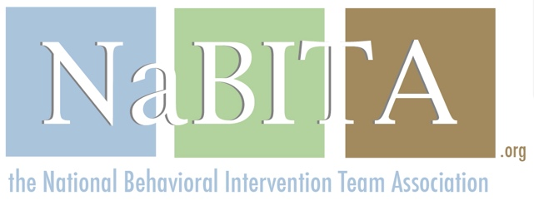

Meals and Snacks Provided by NaBITA during the
2017 NaBITA Conference and Campus Threat Management Institute

NaBITA Conference
Monday, November 13 | Welcome reception  light hors d'oeuvres served
Tuesday, November 14 | Continental Breakfast,  afternoon snack
Wednesday, November 15 | Morning Coffee, buffet lunch

NaBITA Campus Threat Management Institute
Thursday, November 16 | Continental breakfast,  boxed lunch
Friday, November 17 | Continental breakfast

