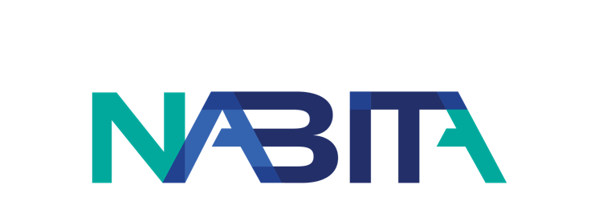
[Date]
From: [Your Name]
To: [Recipient Name]
Re: Request to Attend a Certification Course with National Association for Behavioral Intervention and Threat Assessment (NABITA)
Dear [Recipient Name],
I want to attend the [name of training] Certification Course with NABITA on [date]. Attending this Certification Course will be a valuable investment in my professional development.
NABITA is the premier association for behavioral intervention team training. Top practitioners in the field teach their courses. Attending this training will give me direct access to these experts and allow me to network with other professionals.
In addition to the training, I will learn key takeaways through supplemental materials included in the Course that I can keep and use to reference. Attending the training will also grant me a Certification to verify that I am professionally trained in [Course topic].
NABITA is committed to making schools and workplaces safer environments where development, education, and caring intervention are fostered and encouraged, and professionals from multiple disciplines can come together for mutual support and shared learning. The opportunity to gain knowledge in specific areas, develop better contacts, and share best practices makes my attendance at the 2022 NABITA Annual Conference an investment that broadens my ability to assist [your organization] in becoming a safer environment.
Sincerely,
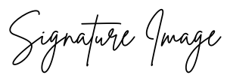
[Name]
[Title]

